*Matthew Yiqing Zhu*

*For Westpac Interview*

*Design*

Project: Simple Weather Information Service

|  |  |  |  |
| --- | --- | --- | --- |
| Version | Author | Create/Update Date | Comments |
| 0.1 | matthew.yiqing.zhu | 2024 05 01 | Initialization |

1. Introduction:

This document is for the project’s code design.

1. High-level view:

* This project is based on spring boot framework with a layered design.
* The controller layer work as web service endpoint to provide the service to the client.
* Service Layer handles the business logic before providing the result to the controller layer.
* The repository/DAO layer queries the data from the mocked database, and pre-process exceptional data (such as null data).
* Mocked In memory database creates recorded data then stores it in the memory handles the query from DAO and returns values.
* Other support classes like Pogo and Utils defined as data structure.

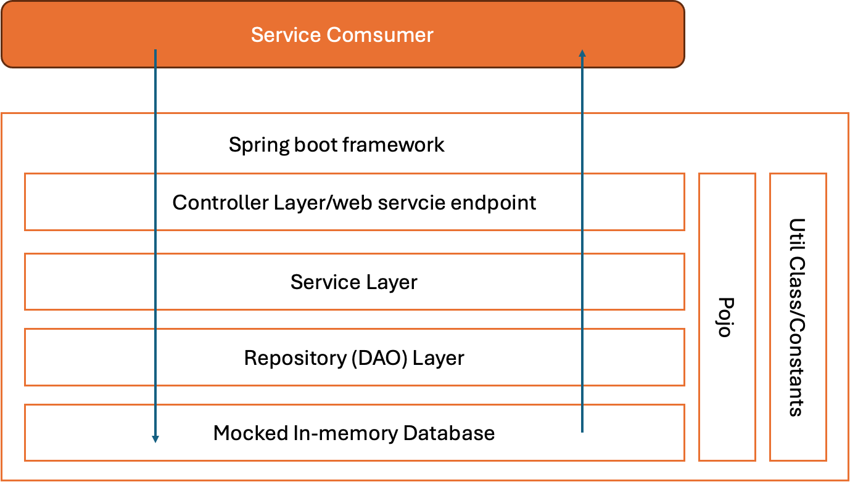

For the detailed design classed in each layer, please refer to the file

“1.2 DetailedDesign.xlsx”